Assignment 6
Raw data:
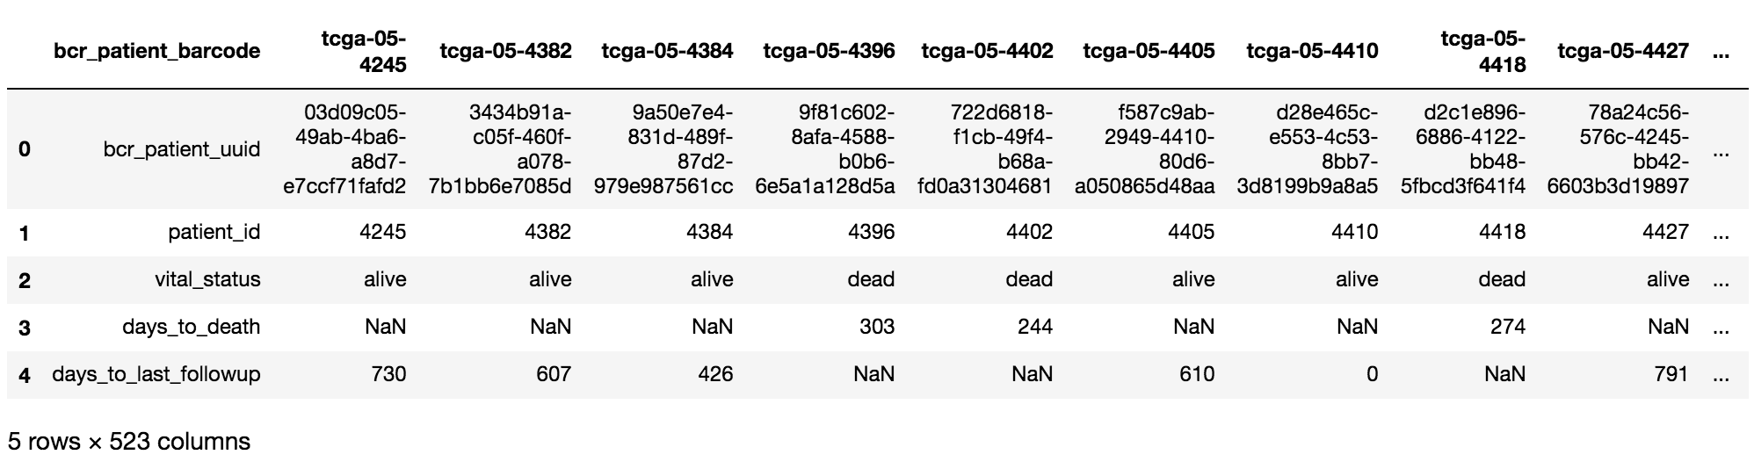

Transpose the dataset and filter for desired stages.
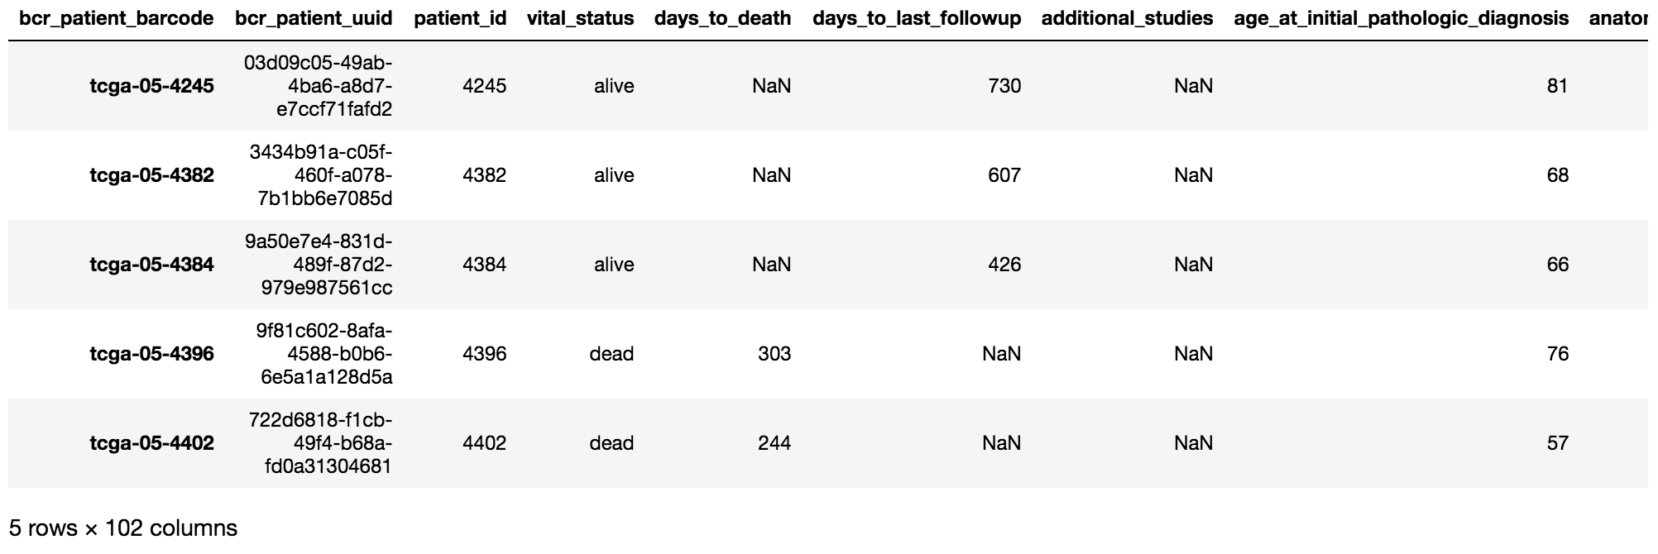
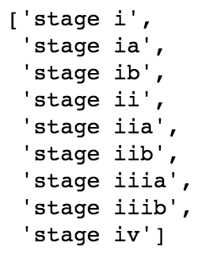

Proportion of each stage by gender:
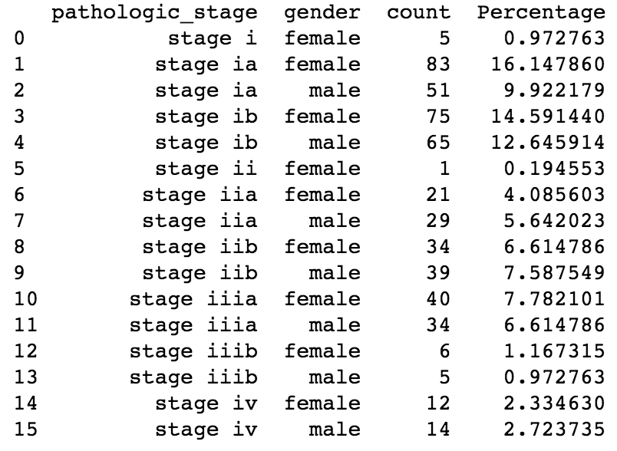

In stacked bar plot:
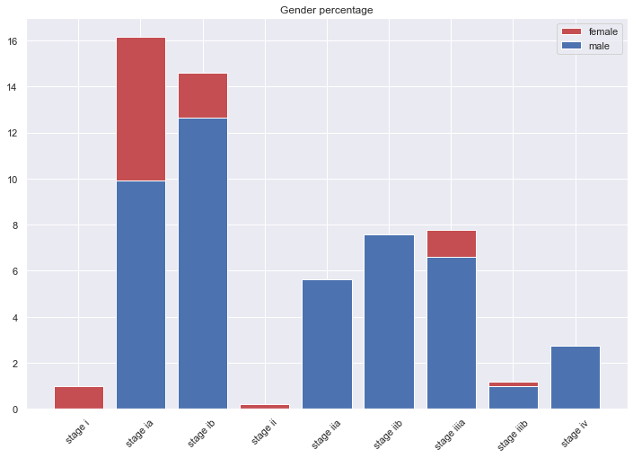

Proportion of each stage by age:
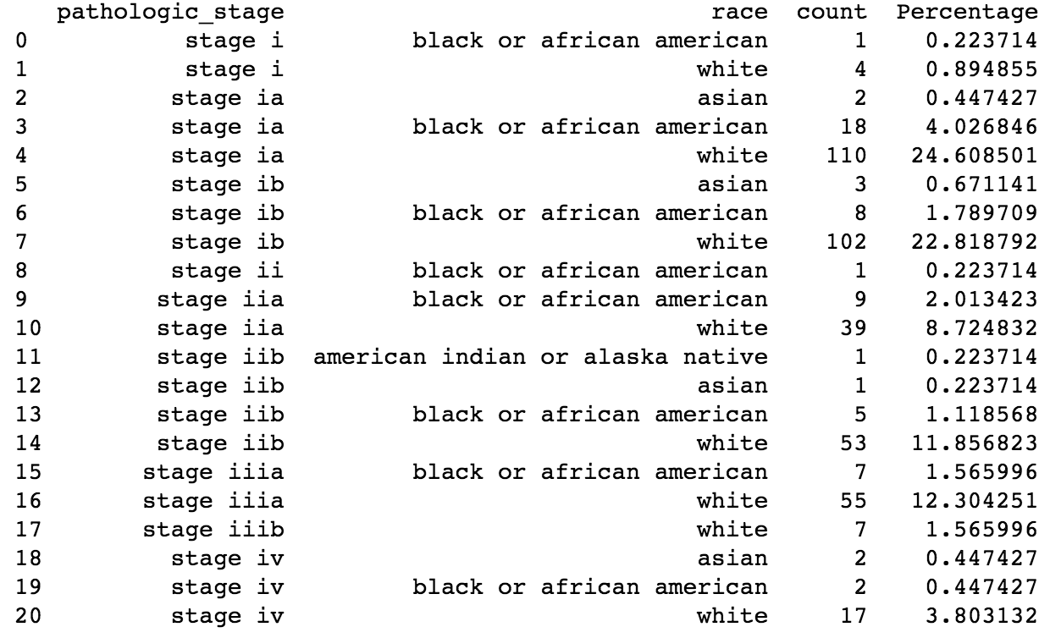

In stacked bar plot:
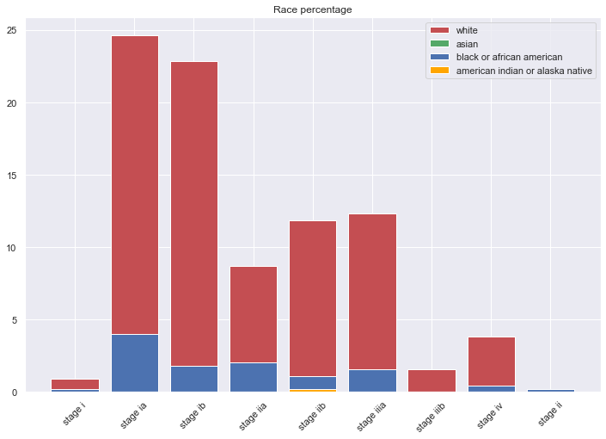

Proportion of each stage by both gender and age:
 | pathologic_stage | gender | race | count | Percentage
0 | stage i | female | black or african american | 1 | 0.22371365
1 | stage i | female | white | 4 | 0.89485459
2 | stage ia | female | asian | 2 | 0.44742729
3 | stage ia | female | black or african american | 14 | 3.13199105
4 | stage ia | female | white | 64 | 14.3176734
5 | stage ia | male | black or african american | 4 | 0.89485459
6 | stage ia | male | white | 46 | 10.2908277
7 | stage ib | female | asian | 2 | 0.44742729
8 | stage ib | female | black or african american | 3 | 0.67114094
9 | stage ib | female | white | 60 | 13.4228188
10 | stage ib | male | asian | 1 | 0.22371365
11 | stage ib | male | black or african american | 5 | 1.11856823
12 | stage ib | male | white | 42 | 9.39597315
13 | stage ii | female | black or african american | 1 | 0.22371365
14 | stage iia | female | black or african american | 3 | 0.67114094
15 | stage iia | female | white | 18 | 4.02684564
16 | stage iia | male | black or african american | 6 | 1.34228188
17 | stage iia | male | white | 21 | 4.69798658
18 | stage iib | female | american indian or alaska native | 1 | 0.22371365
19 | stage iib | female | black or african american | 2 | 0.44742729
20 | stage iib | female | white | 26 | 5.81655481
21 | stage iib | male | asian | 1 | 0.22371365
22 | stage iib | male | black or african american | 3 | 0.67114094
23 | stage iib | male | white | 27 | 6.04026846
24 | stage iiia | female | black or african american | 4 | 0.89485459
25 | stage iiia | female | white | 31 | 6.93512304
26 | stage iiia | male | black or african american | 3 | 0.67114094
27 | stage iiia | male | white | 24 | 5.36912752
28 | stage iiib | female | white | 5 | 1.11856823
29 | stage iiib | male | white | 2 | 0.44742729
30 | stage iv | female | black or african american | 1 | 0.22371365
31 | stage iv | female | white | 7 | 1.56599553
32 | stage iv | male | asian | 2 | 0.44742729
33 | stage iv | male | black or african american | 1 | 0.22371365
34 | stage iv | male | white | 10 | 2.23713647

In stacked bar plot:
